## Activity 3: The International Space Station

The International Space Station orbits around the Earth at a constant speed. Your teacher will give you either a double number line or a table that represents this situation. Your partner will get the other representation.

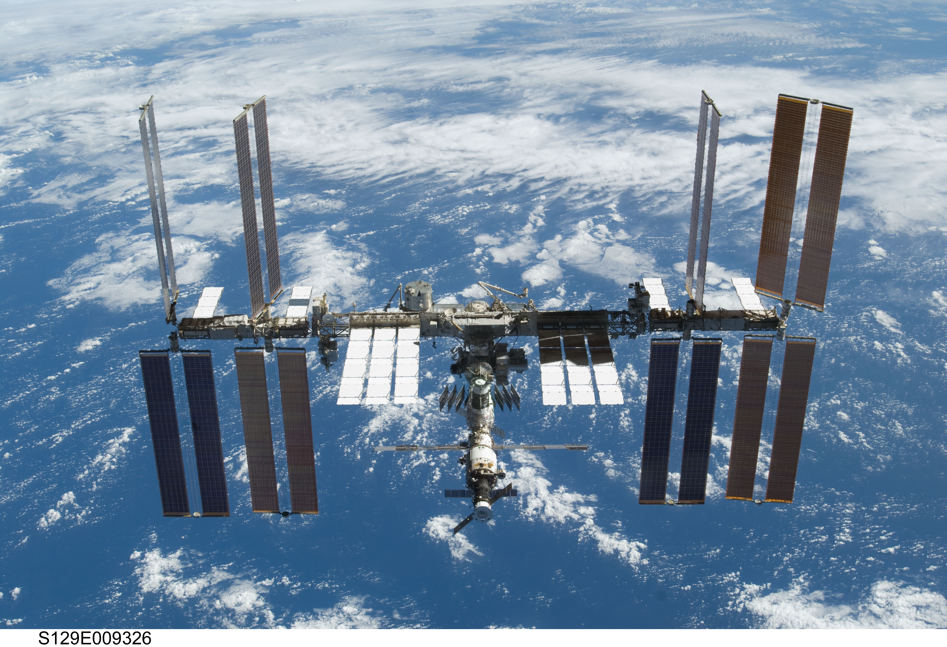

1. Complete the parts of your representation that you can figure out for sure.
2. Share information with your partner, and use the information that your partner shares to complete your representation.
3. What is the speed of the International Space Station?
4. Place the two completed representations side by side. Discuss with your partner some ways in which they are the same and some ways in which they are different.
5. Record at least one way that they are the same and one way they are different.

#### Are you ready for more?

Earth’s circumference is about 40,000 kilometers and the orbit of the International Space Station is just a bit more than this. About how long does it take for the International Space Station to orbit Earth?



© CC BY Open Up Resources. Adaptations CC BY IM.